**Open Shortest Path First (OSPF)**

**Designed Topology:**

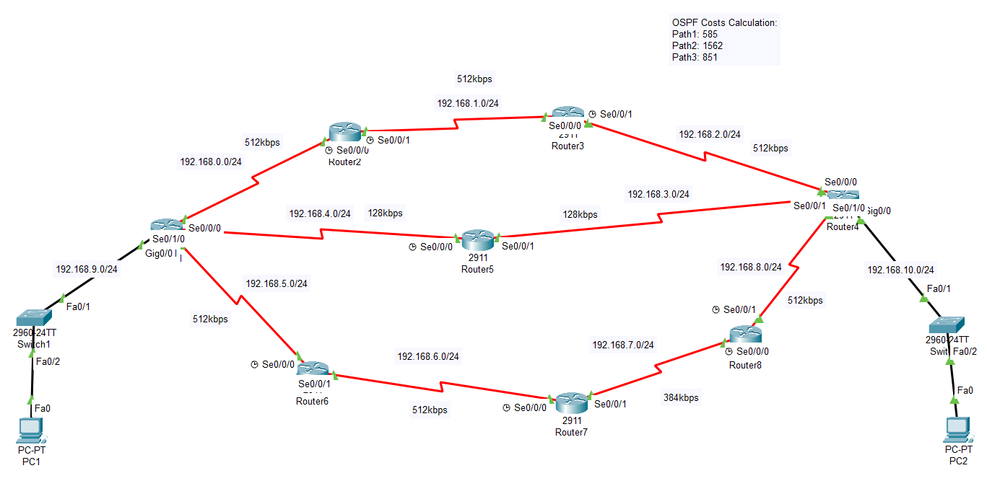

**Configuration of Router1:**

Router>enable

Router#config terminal

Router(config)#hostname R1

R1(config)#int Gig0/0

R1(config-if)#ip address 192.168.9.254 255.255.255.0

R1(config-if)#no shutdown

R1(config)#exit

R1(config)#int Se0/0/0

R1(config-if)#ip address 192.168.0.1 255.255.255.0

R1(config-if)#no shutdown

R1(config-if)#exit

R1(config)#int Se0/0/1

R1(config-if)#ip address 192.168.5.1 255.255.255.0

R1(config-if)#no shutdown

R1(config-if)#exit

R1(config)#int Se0/1/0

R1(config-if)#ip address 192.168.4.1 255.255.255.0

R1(config-if)#no shutdown

R1(config)#router ospf 10

R1(config-router)#network 192.168.0.0 0.0.0.255 area 0

R1(config-router)#exit

R1(config)#router ospf 10

R1(config-router)#network 192.168.4.0 0.0.0.255 area 0

R1(config-router)#exit

R1(config)#router ospf 10

R1(config-router)#network 192.168.5.0 0.0.0.255 area 0

R1(config-router)#exit

R1(config)#router ospf 10

R1(config-router)#network 192.168.9.0 0.0.0.255 area 0

R1(config-router)#exit

R1(config)#int Se0/0/0

R1(config-if)#bandwidth 512

R1(config-if)#exit

R1(config)#int Se0/1/0

R1(config-if)#bandwidth 128

R1(config-if)#exit

R1(config)#int Se0/0/1

R1(config-if)#bandwidth 512

R1(config-if)#exit

R1(config)#exit

R1#write

**Configuration of Router2:**

Router>enable

Router#config terminal

Router(config)#hostname R2

R2(config)#int Se0/0/0

R2(config-if)#ip address 192.168.0.2 255.255.255.0

R2(config-if)#no shutdown

R2(config-if)#exit

R2(config)#int Se0/0/1

R2(config-if)#ip address 192.168.1.1 255.255.255.0

R2(config-if)#no shutdown

R2(config-if)#exit

R2(Config)#int Se0/0/0

R2(config-if)#clock rate 64000

R2(config-if)#exit

R2(config)#int Se0/0/1

R2(config-if)#clock rate 64000

R2(config-if)#exit

R2(config)#router ospf 20

R2(config-router)#network 192.168.0.0 0.0.0.255 area 0

R2(config-router)#exit

R2(config)#router ospf 20

R2(config-router)#network 192.168.1.0 0.0.0.255 area 0

R2(config-router)#exit

R2(config)#int Se0/0/0

R2(config-if)#bandwidth 512

R2(config-if)#exit

R2(config)#int Se0/0/1

R2(config-if)#bandwidth 512

R2(config-if)#exit

R2(config)#exit

R2#write

**Configuration of Router3:**

Router>enable

Router#config terminal

Router(config)#hostname R3

R3(config)#int Se0/0/0

R3(config-if)#ip address 192.168.1.2 255.255.255.0

R3(config-if)#no shutdown

R3(config-if)#exit

R3(config)#int Se0/0/1

R3(config-if)#ip address 192.168.2.1 255.255.255.0

R3(config-if)#no shutdown

R3(config-if)#exit

R3(config)#int Se0/0/1

R3(config-if)#clock rate 64000

R3(config-if)#exit

R3(config)#router ospf 30

R3(config-router)#network 192.168.1.0 0.0.0.255 area 0

R3(config-router)#exit

R3(config)#router ospf 30

R3(config-router)#network 192.168.2.0 0.0.0.255 area 0

R3(config-router)#exit

R3(config)#int Se0/0/0

R3(config-if)#bandwidth 512

R3(config-if)#exit

R3(config)#int Se0/0/1

R3(config-if)#bandwidth 512

R3(config-if)#exit

R3(config)#exit

R3#write

**Configuration Router4:**

Router>enable

Router#config terminal

Router(config)#hostname R4

R4(config)#int Gig0/0

R4(config-if)#ip address 192.168.10.254 255.255.255.0

R4(config-if)#no shutdown

R4(config-if)#exit

R4(config)#int Se0/1/0

R4(config-if)#ip address 192.168.3.2 255.255.255.0

R4(config-if)#no shutdown

R4(config-if)#exit

R4(config)#int Se0/0/0

R4(config-if)#ip address 192.168.2.2 255.255.255.0

R4(config-if)#no shutdown

R4(config-if)#exit

R4(config)#int Se0/0/1

R4(config-if)#ip address 192.168.8.2 255.255.255.0

R4(config-if)#no shutdown

R4(config-if)#exit

R4(config)#int Se0/1/0

R4(config-if)#clock rate 64000

R4(config-if)#exit

R4(config)#router ospf 40

R4(config-router)#network 192.168.2.0 0.0.0.255 area 0

R4(config-router)#exit

R4(config)#router ospf 40

R4(config-router)#network 192.168.3.0 0.0.0.255 area 0

R4(config-router)#exit

R4(config)#router ospf 40

R4(config-router)#network 192.168.8.0 0.0.0.255 area 0

R4(config-router)#exit

R4(config)#router ospf 40

R4(config-router)#network 192.168.10.0 0.0.0.255 area 0

R4(config-router)#exit

R4(config)#int Se0/0/0

R4(config-if)#bandwidth 512

R4(config-if)#exit

R4(config)#int Se0/1/0

R4(config-if)#bandwidth 128

R4(config-if)#exit

R4(config)#int Se0/0/1

R4(config-if)#bandwidth 512

R4(config-if)#exit

R4(config)#exit

R4#write

**Configuration of Router5:**

Router>enable

Router#config terminal

Router(config)#hostname R5

R5(config)#int Se0/0/0

R5(config-if)#ip address 192.168.4.2 255.255.255.0

R5(config-if)#no shutdown

R5(config-if)#exit

R5(config)#int Se0/0/1

R5(config-if)#ip address 192.168.3.1 255.255.255.0

R5(config-if)#no shutdown

R5(config-if)#exit

R5(config)#int Se0/0/0

R5(config-if)#clock rate 64000

R5(config-if)#exit

R5(config)#router ospf 50

R5(config-router)#network 192.168.3.0 0.0.0.255 area 0

R5(config-router)#exit

R5(config)#router ospf 50

R5(config-router)#network 192.168.4.0 0.0.0.255 area 0

R5(config-router)#exit

R5(config)#int Se0/0/0

R5(config-if)#bandwidth 128

R5(config-if)#exit

R5(config)#int Se0/0/1

R5(config-if)#bandwidth 128

R5(config-if)#exit

R5(config)#exit

R5#write

**Configuration of Router6:**

Router>enable

Router#config terminal

Router(config)#hostname R6

R6(config)#int Se0/0/0

R6(config-if)#ip address 192.168.5.2 255.255.255.0

R6(config-if)#no shutdown

R6(config-if)#exit

R6(config)#int Se0/0/1

R6(config-if)#ip address 192.168.6.1 255.255.255.0

R6(config-if)#no shutdown

R6(config-if)#exit

R6(config)#int Se0/0/0

R6(config-if)#clock rate 64000

R6(config-if)#exit

R6(config)#R6 ospf 60

R6(config-R6)#network 192.168.5.0 0.0.0.255 area 0

R6(config-R6)#exit

R6(config)#router ospf 60

R6(config-router)#network 192.168.6.0 0.0.0.255 area 0

R6(config-router)#exit

R6(config)#int Se0/0/0

R6(config-if)#bandwidth 512

R6(config-if)#exit

R6(config)#int Se0/0/1

R6(config-if)#bandwidth 512

R6(config-if)#exit

R6(config)#exit

R6#write

**Configuration of Router7:**

Router>enable

Router#config terminal

Router(config)#hostname R7

R7(config)#int Se0/0/0

R7(config-if)#ip address 192.168.6.2 255.255.255.0

R7(config-if)#no shutdown

R7(config-if)#exit

R7(config)#int Se0/0/1

R7(config-if)#ip address 192.168.7.1 255.255.255.0

R7(config-if)#no shutdown

R7(config-if)#exit

R7(config)#int Se0/0/0

R7(config-if)#clock rate 64000

R7(config-if)#exit

R7(config)#router ospf 70

R7(config-router)#network 192.168.6.0 0.0.0.255 area 0

R7(config-router)#exit

R7(config)#router ospf 70

R7(config-router)#network 192.168.7.0 0.0.0.255 area 0

R7(config-router)#exit

R7(config)#int Se0/0/0

R7(config-if)#bandwidth 512

R7(config-if)#exit

R7(config)#int Se0/0/1

R7(config-if)#bandwidth 384

R7(config-if)#exit

R7(config)#exit

R7#write

**Configuration of Router8:**

Router>enable

Router#config terminal

Router(config)#hostname R8

R8(config)#int Se0/0/0

R8(config-if)#ip address 192.168.7.2 255.255.255.0

R8(config-if)#no shutdown

R8(config-if)#exit

R8(config)#int Se0/0/1

R8(config-if)#ip address 192.168.8.1 255.255.255.0

R8(config-if)#no shutdown

R8(config-if)#exit

R8(config)#int Se0/0/0

R8(config-if)#clock rate 64000

R8(config-if)#exit

R8(config)#int Se0/0/1

R8(config-if)#clock rate 64000

R8(config-if)#exit

R8(config)#router ospf 80

R8(config-router)#network 192.168.7.0 0.0.0.255 area 0

R8(config-router)#exit

R8(config)#router ospf 80

R8(config-router)#network 192.168.8.0 0.0.0.255 area 0

R8(config-router)#exit

R8(config)#int Se0/0/0

R8(config-if)#bandwidth 384

R8(config-if)#exit

R8(config)#int Se0/0/1

R8(config-if)#bandwidth 512

R8(config-if)#exit

R8(config)#exit

R8#write

**Displaying the OSPF routing table:**

**Displaying information about the OSPF neighbors:**

**Displaying the current routing table:**

**Displaying detailed information about the OSPF Link State Database:**

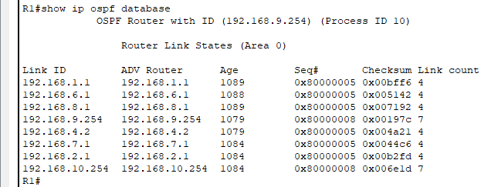

**Displaying information about the routing protocols:**

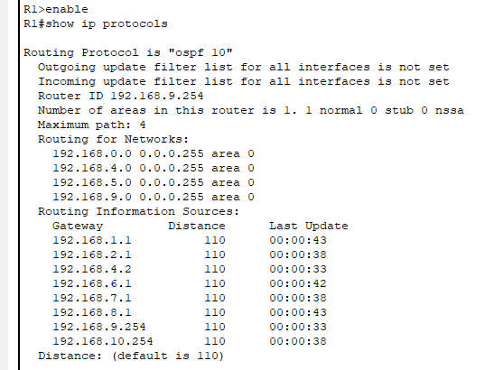

**Displaying detailed information about the OSPF:**

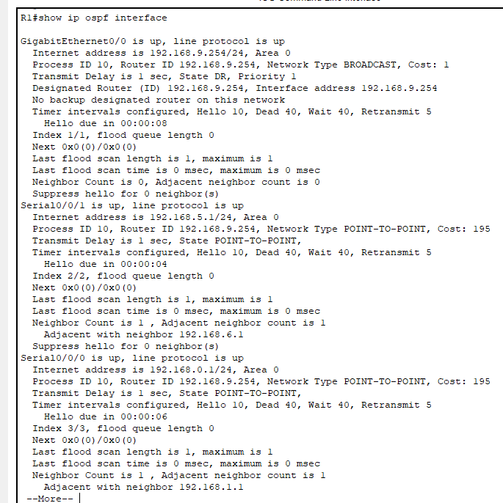



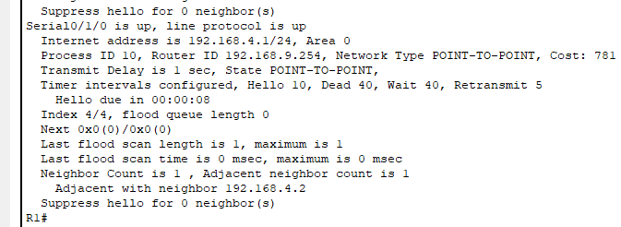

**IP Configuration of PC1:**

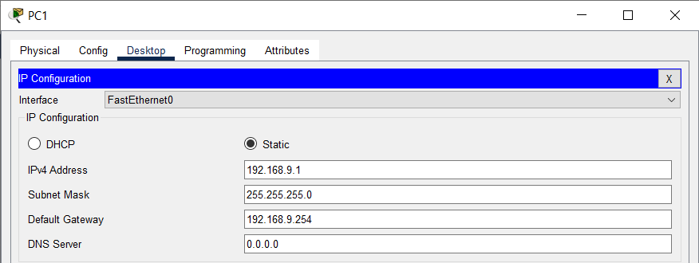

**IP Configuration of PC2:**

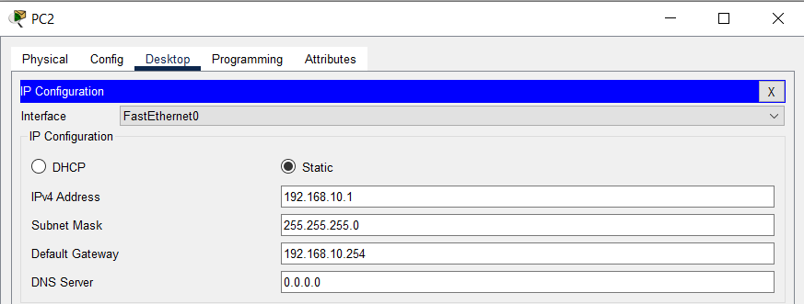

**Checking Connectivity by Pinging:**

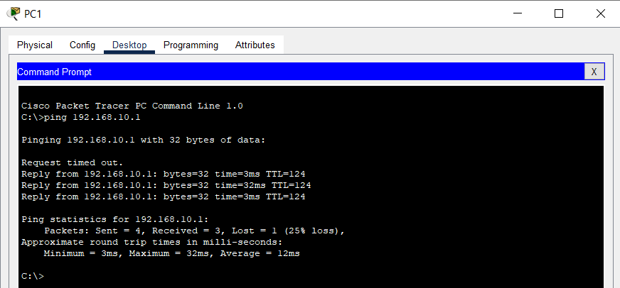

**Note:**

The OSPF cost (metric) of Path 1 is 585. As we are aware, the OSPF routing protocol always selects the optimal route (Open Shortest Path First). Therefore, when initiating a ping from PC1 to PC2, Path 1 will be utilized.

If we deactivate the interface Se0/0/0 (bring it down), the OSPF routing protocol will choose the next best route, which is Path 3, based on the Open Shortest Path First (OSPF) algorithm. The SPF cost (metric) for Path 3 is 851. Consequently, when initiating a ping from PC1 to PC2, Path 3 will be utilized.

If we deactivate the interface Se0/0/1, the OSPF routing protocol will choose the third and final optimal route based on the Open Shortest Path First (OSPF) algorithm, which is Path 2. The SPF cost (metric) for Path 2 is 1562. As a result, when initiating a ping from PC1 to PC2, Path 2 will be utilized.

You can calculate the OSPF Cost from given formula:

Cost= 108/interface bandwidth in bps

Following table lists OSPF Default Cost values for different interfaces bandwidths:

